PONDER 03: ELICITATION DATA

Ryan L. Dockstader

# Technique Information

**Name:** Questionnaire

For my elicitation data, I decided to employ the questionnaire technique. I was sure to keep my questionnaire short, and have a few open ended questions.

# Stakeholder Information

For my stakeholders, since this is supposed to be an iOS/android application, I wanted to get as many people surveyed as possible. For this, I posted on a work slack, on my Facebook, and messaged a few people directly asking them to fill out the survey. This allowed for a range of ages, backgrounds, etc.

# Methodology Information

I used a Google Form, and provided a link to as many people as possible. The questions on the questionnaire were:

1. What would be the most important feature to you for this type of application?
2. What is the most important security feature to you?
3. Briefly explain your ideal security for this type of app:
4. Would you be likely to use this type of app?
5. Explain why or why not you would use this app
6. In what situation would an app like this be the most beneficial for you?

Since my team lead told me I would be over the security section, I focused some of my questions on the security aspects of the application.

# Data

## What would be the most important feature to you for this type of application?

* User friendly and easy/fast to use.
* Storage
* Simple and intuitive categories
* The ability to quickly enter info
* Ease of entry
* Easy to input info.
* The ability to add my own fields to use for labels.
* Knowing what i have and its value
* User friendly
* Easy to enter things.
* A keyword search function
* To keep track of everything
* A quality level or remaining life level.
* Price
* Simplicity to use (easy to add to and easy to recall data)
* Organization and user ease
* Adding a picture of the receipt.
* Ease of access, able to get data off cloud if my phone is the thing that is lost

## What is the most important security feature to you?

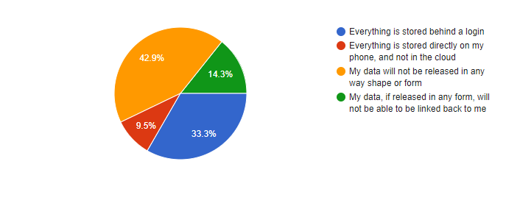

## Briefly explain your ideal security for this type of app

* Keep secure. I don't want anyone to know all the stuff I have in my house. Give them an invitation to Rob me.
* Guarded by Skynet AI technology
* No PII whatsoever
* simple log in, I'm not storing "personal" data.
* current and up to date encryption method for data transportation.
* Much security. Passwords. Encrypted data. All the good stuff.
* I can use the fingerprint scanner on my phone to login.
* Personal password, 6 digit pin,security questions, & picture login
* Not easy to hack
* If my data is released to other companies (ie for market research) and the app developer is compensated financially for it, those who's data would be used should have the option to opt out or be paid for their contribution
* Login
* I don't want anymore data out there than is already out there
* 2 factor log in
* I also would llike the data if released not able to be linked back to me.
* Less accessible to break into if it’s not in the cloud
* simple login with thumb reader, data storage for "cloud" or local on the phone.
* Multi-factor
* Requires a login.
* Login would be good. My concern would be 3rd party interest in the data.
* 2 factor authentication or integration with smartphone biometric scanners.

## Would you be likely to use this type of app?

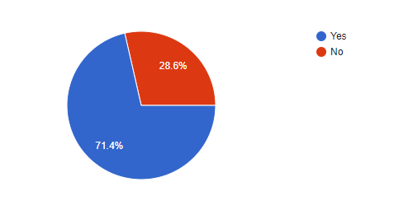

## Explain why or why not you would use this app

### Yes, I would use it

* I would use this app because i buy cool stuff, and honestly the level of cool stuff i have should be documented and replicated.. i have a commando mural.. enough said.
* Easy way to inventory things for insurance quotes.
* for non-consumable items, it would be good for reference, possibly budget planning, when selling the item, or as stated above, for insurance.
* Seems like it would be handy to have. Most financial experts recommend you do this but it’s so time consuming and cumbersome I’m guessing not many people actually do.
* Sounds like it would be useful in inventory & insurance reasons
* Its always good to have an inventory in case of theft. It also would help with buying the same thing again because you couldn't remember if you had one
* It would be handy
* I'm interested in minimizing the things I own.
* It would be helpful to have all that info stored in one place
* As a home owner, it would make a HUGE difference with claims and in the unlikely occurrence of a fire, it is all stored and make insurance less of a pain.
* I never track my warranty information and this could help with that.
* I think the reasons you mentioned make sense to me. Saving informing for quick easy lookup if you wanted to sell the item, appraise the item, or make an insurance claim. It could also be a good record for tax documentation for donations.
* I currently have a paper ledger to keep track of important purchases so if this would be easier and a more redundant way of storing that information

### No, I wouldn’t use it

* Seems like a good idea but kind of a pain to track all your stuff you buy. Probably only use for big purchases.
* No reason to track what i have in my house
* For me I don't see a reason for me to use it other then being like the little mermaid. "look at this stuff isn't it neat"
* I don’t own enough now
* I'm very very lazy and unless it didn't add to thing to do in my life I wouldn't use it...
* I'm too lazy to take the time

# In what situation would an app like this be the most beneficial for you?

* Insurance claim for house fire.
* sometimes you forget what you buy, where your money goes or you want to sell something and can't remember what you paid for it or where it was purchased from.
* Home business
* for firearm purchases. In order to insure firearms, you have to provide itemized statements to the insurance company and this would be an easy way to do it.
* I think most of the time, it would be when I'm conversing with someone, and need to answer how much it cost.
* Fire or theft.
* Maybe if I was moving and wanted to make sure everything got to the new place.
* Inventory, insurance, and theft protection.
* Maybe in ten years as a home owner
* If all my things got stolen I would have proof for insurance
* Insurance claim/police report
* Insurance
* To keep track of everything
* Through an effort of simplifying my life.
* With resale of items, or just curiosity of what I paid for that back in the day. I would also use it for budgeting.
* Moving
* insurance claim is the first, second would be if i needed to do any warranty type data or wanting to resale an item.
* In emergencies for insurance
* In the event of a loss where insurance claims were being made. The cloud option would be necessary for this situation, because your phone may have also been damaged, lost, or stolen.
* Items of a certain type or value. Appliances, tools, electronics.
* Big purchases